## MS Data Analysis Capstone Project

2019

Business Intelligence/Data Analytics Project: Healthcare Readmission Reduction. SAS Studio and Tableau Tools. Analysis identifying medical providers with high readmission rates. Data can be used to lower provider costs associated with unnecessary patient readmissions. The study identifies medical centers that have poor discharge procedures incurring high penalty costs. Created visualizations of data to support business decisions to improve medical practices. The research question and research hypothesis for the study are formed by understanding what the dataset and variables can deliver.)

# Dataset

The Hospital Readmissions Reduction Program dataset can be found at link API: https://data.medicare.gov/api/views/9n3s-kdb3/rows.csv?accessType=DOWNLOAD. The dataset is comprised of variables such as hospital names, the number of discharges, predicted readmission rate, expected readmission rate, and actual number of readmissions for analysis and review, and 19,674 records. The relationship between the dataset variables may not conclude a summary statistic in start date, end date, and inpatient mortality, however, a summary statistic between variable number of discharges and the actual number of readmissions can be evaluated for analysis. This may conclude a hospital’s practice to keep patients longer as needed for patient’s improved health and not for the avoidance of fatality rates. Overall, the prediction of the Hospital Readmission Reduction Act may not be totally determined by the analyzation of the variables in the dataset, however, a step closer to understanding the relationship and summary statistic between the variables and hospitals.

## Programming Code, Screenshots1

The programming code is the most important part of SAS. The code gives details as how to manipulate the dataset. First, the dataset is saved in CSV comma delimited format. The file is imported into SAS and saved.

FILENAME REFFILE '/folders/myfolders/sasuser.v94/Hospital_Readmissions_Reduction_Program (1).csv';

PROC IMPORT DATAFILE=REFFILE

DBMS=CSV

OUT=WORK.IMPORT;

GETNAMES=YES;

RUN;

PROC CONTENTS DATA=WORK.IMPORT;

RUN;

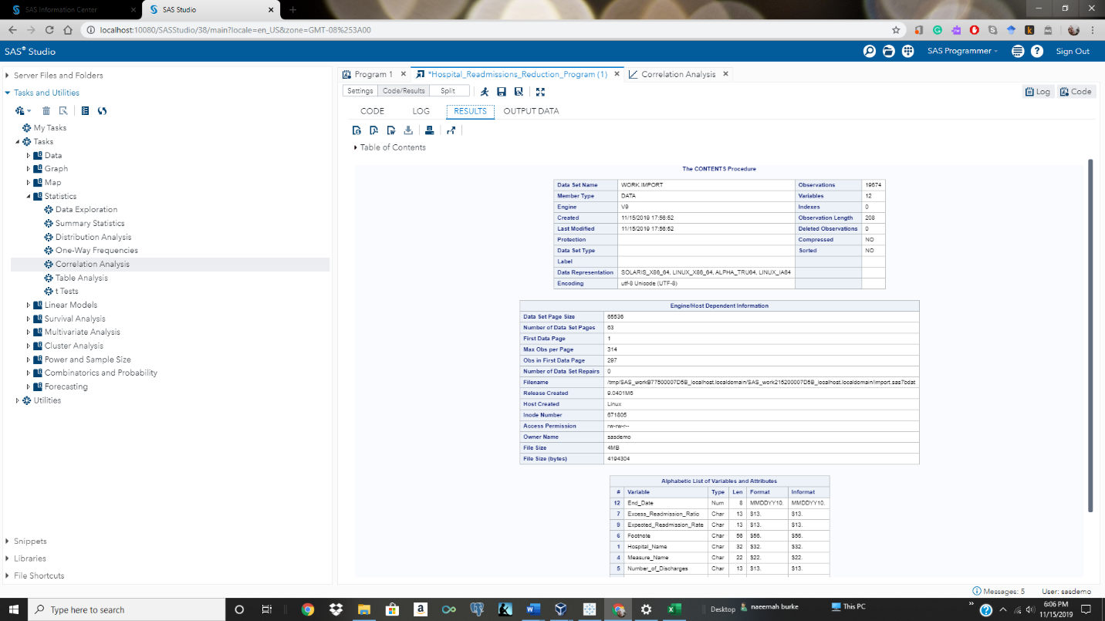

The results shown above depict an SAS table. The data set WORK.IMPORT has 19674 observations and 12 variables.

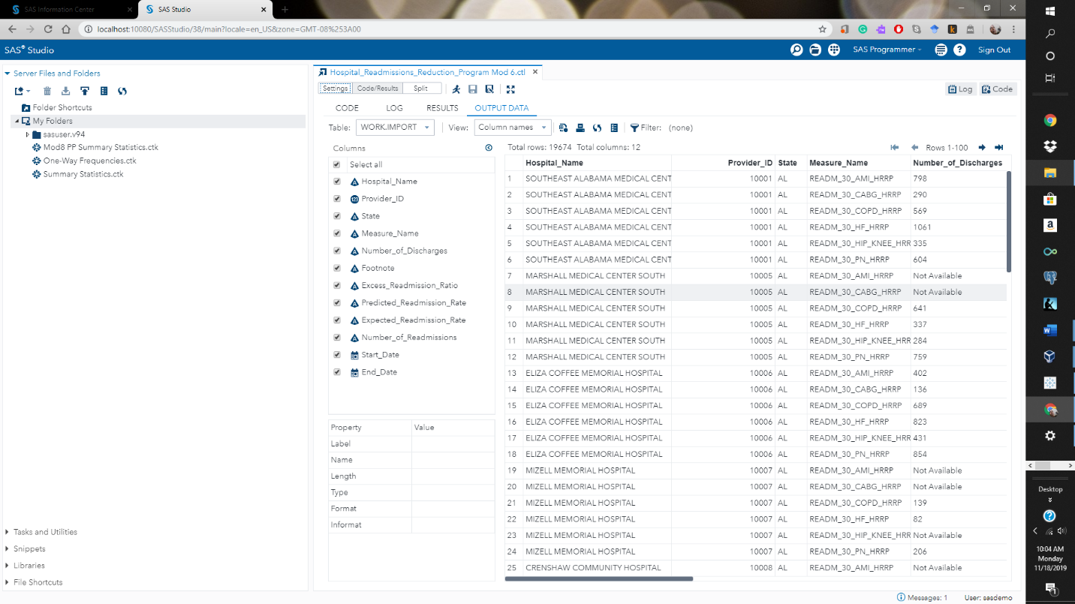

The summary statistical analysis provides graphs and statistics from the dataset and locates groups among the 12 variables. Find the summary statistic between the variables; provider_id and number readmissions.

PROC MEANS DATA=WORK.IMPORT CHARTYPE MEAN STD MIN MAX N VARDEF=DF;

VAR PROVIDER_ID;

CLASS NUMBER_OF_READMISSIONS;

RUN;

PROC UNIVARIATE DATA=WORK.IMPORT VARDEF=DF NOPRINT;

VAR PROVIDER_ID;

CLASS NUMBER_OF_READMISSIONS;

HISTOGRAM PROVIDER_ID;

RUN;

The results indicate hospital provider_id’s; 70022 Yale-New Haven and 340040 Vidant Medical

Center represents hospitals with the highest readmissions in the dataset.

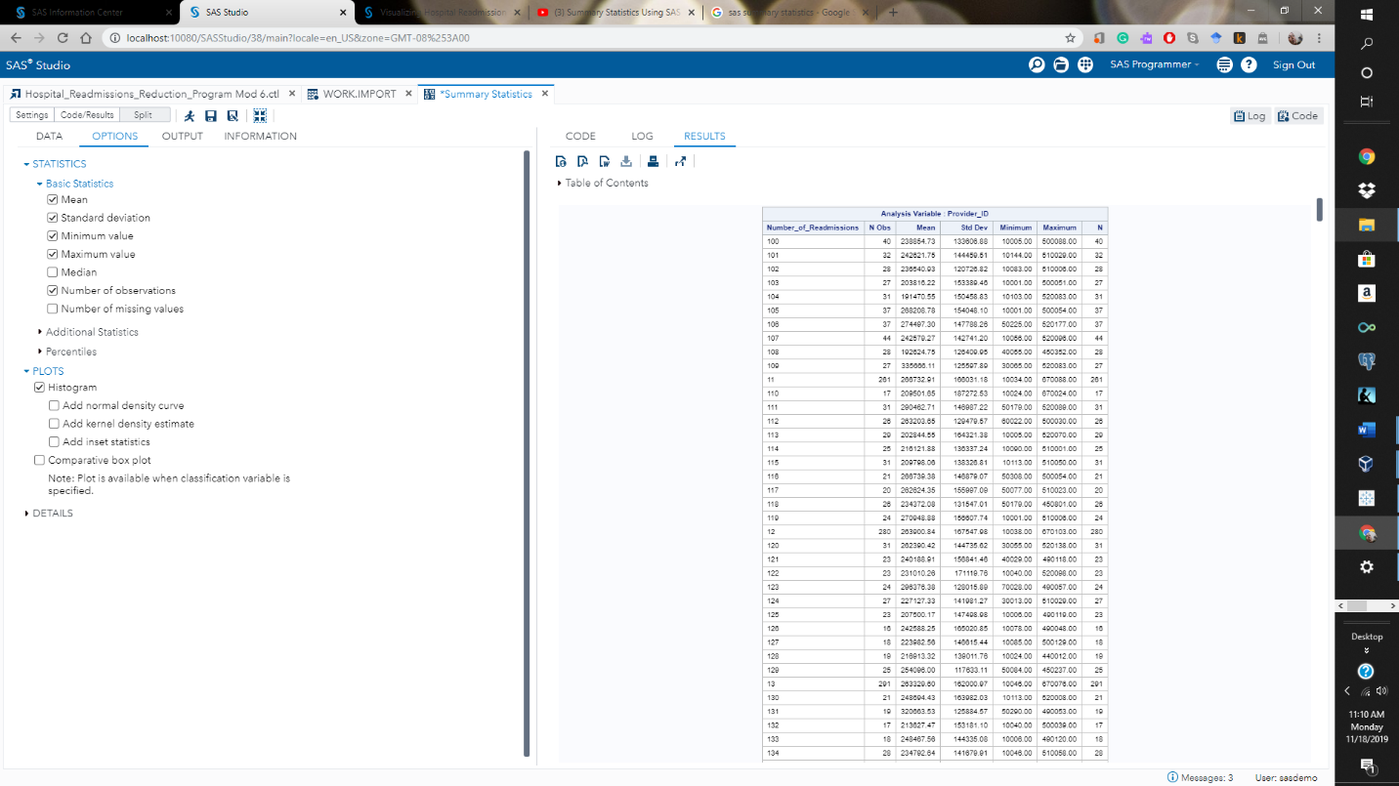

Tableau analysis and visualization tool allows for enhanced business intelligence which makes data easier to understand leading to better business decisions.

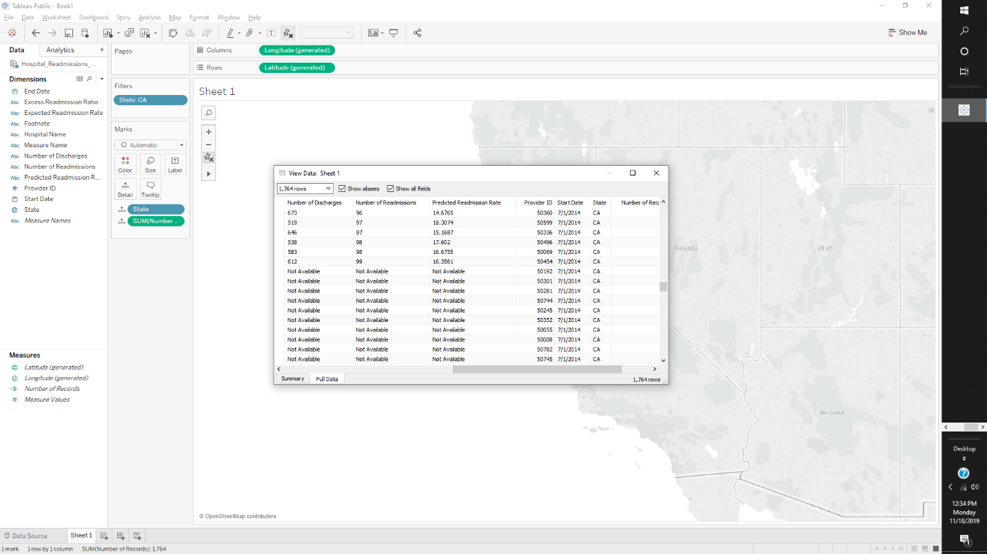

The visualization of a bar chart reveals hospital data, the number of the hospital, and readmission rates.

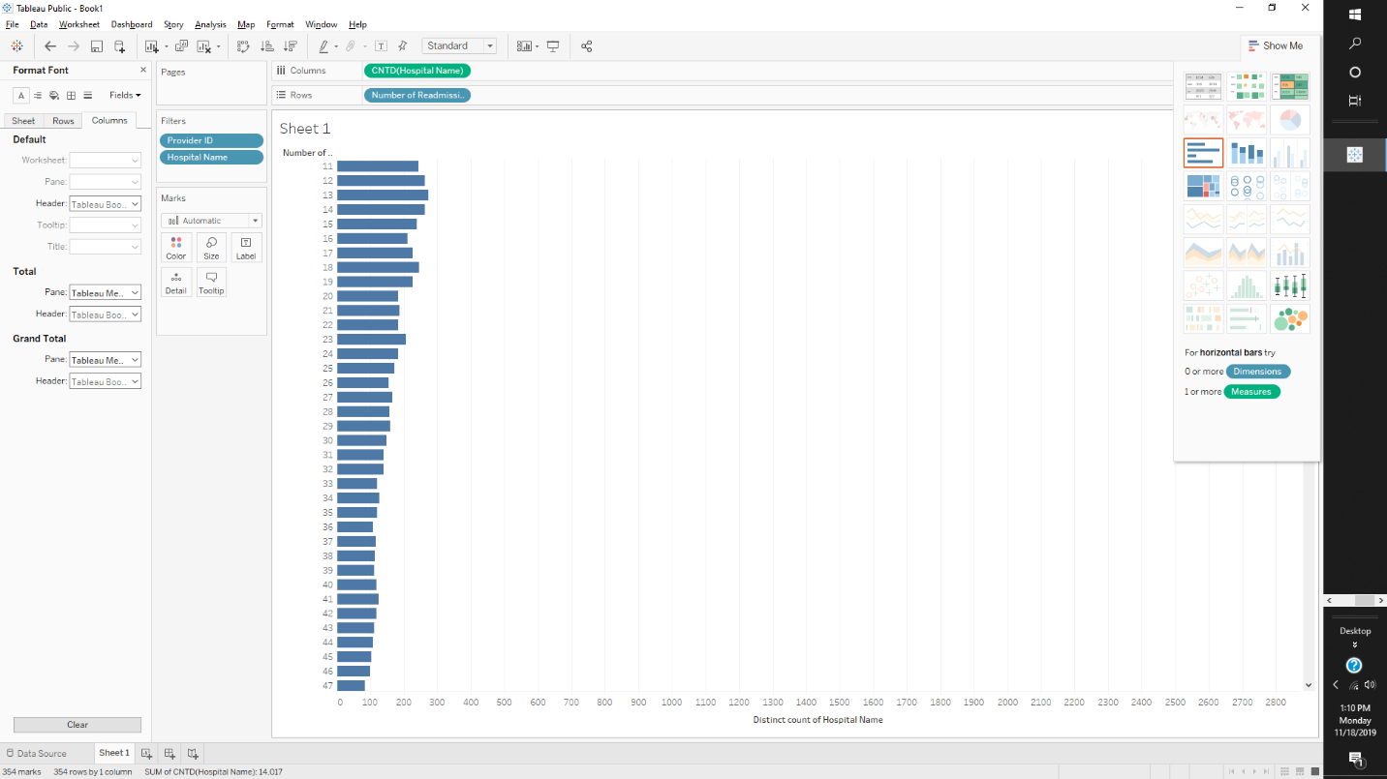

### GitHub.

Https://github.com/naeemah-byte/Hospital-Readmission-Recuction-Mod-6

